# Lab X: Module 1 Lab 1: JavaScript Hello World

# Brandon Trinkle

# IFT 458: Middleware Prog & Database Sec

# Professor: Dinesh Sthapit

# Jan 17, 2025

## Lab 1: JavaScript Hello World

Task 1: Create a Project

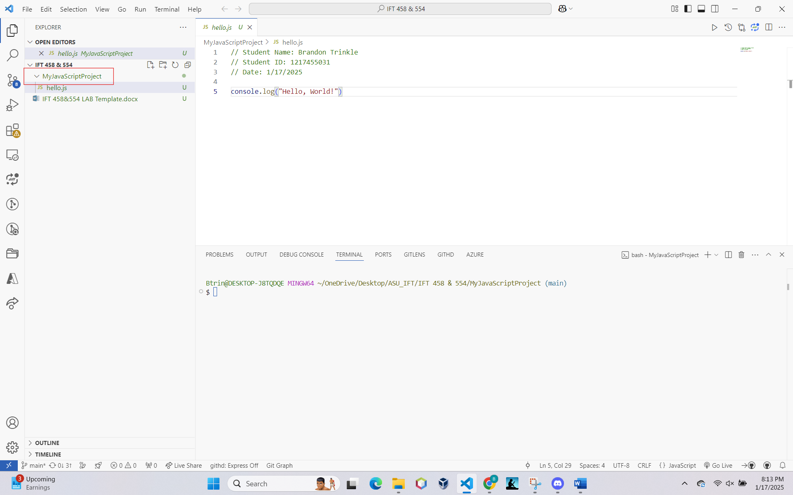

Task 2: Create a JavaScript File

Task 3: Write a JavaScript Program

Task 4: Execute the JavaScript File

